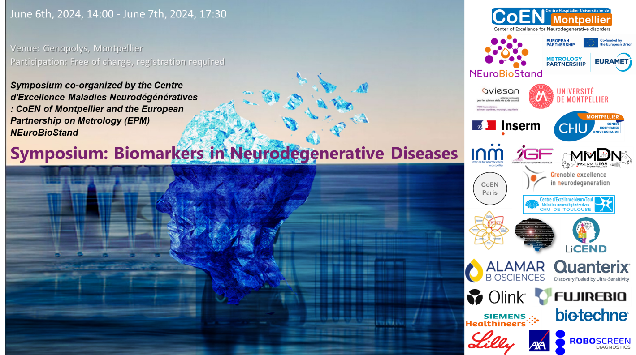

**Symposium: Biomarkers in Neurodegenerative Diseases**

**Thursday 6th of June 2024 (14h-18h10)**

**14h00 Introduction of the congress**

**SESSION 1 : Standardization and Normative Frameworks in Neurodegenerative Disease Blood Biomarkers**

*Chairmann: Henrik Zetterberg*

**14h30 Chiara Giangrande (LNE, Paris)**

*30’ Standardisation of Measurements of Neurodegenerative Disease Biomarkers: The NEuroBioStand Project.*

**15h00 Charlotte Teunissen (VUMC, Amsterdam)**

*30’ Addressing Preanalytical Variability: Towards Reliable Blood Biomarker. Assessments in Neurodegenerative Disorders.*

**15h30 Sylvain Lehmann (CoEN Montpellier, CHU, Montpellier)**

*30’ Establishing Population-Specific Norms: for Blood Biomarkers in neurodegenerative Disorders through the AXA Interval Project.*

**16h00-16h30 Coffee Break**

**SESSION 2 : Biomarkers in Neurodegenerative Diseases using Omics / IA**

*Chairmann: Chiara GIAGRANDE*

**16h30 Johan Gobom (University of Gothenburg)**

*15’*  *Mass spectrometric measurement of pTau in CSF and plasma.*

**16h45 Cristian Arsene (PTB, Braunschweig)**

*15’ Xlinking MS for structure analysis of tau/phosphorylated tau and other proteins.*

**17h00 Dorian Manouvrier (LiCeND, University of Lille, Inserm, CHU Lille, Lille Neuroscience & Cognition)**

*15’* *Artificial intelligence applied to imaging in Alzheimer’s disease.*

**Sponsor session**

*Chairmann: Mehdi MORCHIKH*

**17h15 GOLD SPONSOR - ALAMAR**

*15’**A new ultra-sensitive proteomics platform for profiling low abundant fluid-based inflammatory and neurodegenerative disease biomarkers in highly multiplex panels*

**17h30-18h10: Plenary Session**

*Chairmann: Sylvain LEHMANN*

**17h30 Henrik Zetterberg (University of Gothenburg)**

*40’* *Fluid Biomarkers for Neurodegenerative Dementias: Brawlers, Bawlers and Bastards*

**Friday 7th of June 2024 (8h30-17h00)**

**8h30 Welcoming Coffee**

**8h30 Welcoming**

**SESSION 3 : Biomarkers in Synucleinopathies**

*Chairmann: Johan Gobom*

**9h00 Sabrina Boulet and Florence Fauvelle (Green, GIN, Grenoble)**

*30’ A blood metabolic biomarker for Parkinson disease early diagnosis and potential therapeutic target.*

**9h30 Olivier Rascol (Neurotoul, CHU, Toulouse)**

*30’* *Clinical trial and biomarker: lixisenatide in Parkinson disease*

**10h00-10h30: Coffee Break**

**SESSION 4 : Biomarkers in Alzheimer's Disease**

*Chairmann: Charlotte Teunissen*

**10h30 Vincent Planche (BIND, CHU Bordeaux)**

*30’**Blood biomarkers of Alzheimer's Disease: insights from the MEMENTO cohort.*

**11h00 Nicolas Villain (IM2A, Sorbonne University, Paris)**

*30’**Biomarkers of Alzheimer's disease.*

**11h30 Aude Nicolas (LiCeND, Institut Pasteur, Lille)**

*30’ Transferability of a European-derived Alzheimer’s Disease Genetic Risk Score across Multi-Ancestry Populations.*

**SESSION 5 (1st part) : Biomarkers in other Neurodegenerative diseases**

*Chairmann: Olivier Rascol*

**12h00 Peter Körtvélyessy (Charité University hospital, Berlin)**

*15’ NfL in ALS and FTD.*

**12h15 14h00: Lunch break + Poster session**

**14h00-15h00: Plenary session**

*Chairmann: Sylvain Lehmann*

**14h00 Luc Buée (LiCeND, University of Lille, Inserm, CHU Lille, Lille Neuroscience & Cognition)**

*40’**The tau protein... born to be a biomarker...*

**Sponsor session**

*Chairmann: Mehdi MORCHIKH*

**15h00 : GOLD SPONSOR - QUANTERIX**

*15’**Simoa® Technology for Ultrasensitive Biomarker Detection: Translational blood based neurological biomarkers and beyond*

**15h15 : GOLD SPONSOR – OLINK**

*15’**Olink Proteomics - From bench to clinical enablement : Next generation Multiplex Protein measurement to accelerate Precision Medicine.*

**SESSION 5 (2nd part) : Biomarkers in other Neurodegenerative diseases**

*Chairmann: Olivier Rascol*

**15h30 David Bendetowicz (BIND, CHU, Bordeaux)**

*15’ Advances in biofluid markers for multiple system atrophy.*

**15h45 Natalia Del Campo (Neurotoul, CHU, Toulouse)**

*15’ Imaging and biological Biomarkers in a cohort of patients with MSA.*

**SESSION 6: Microbiota Biomarkers**

*Chairmann: Philippe Marin*

**16h00 Sylvie Claeysen (IGF, Montpellier)**

*20’ Microbiota and gut-derived biomarkers in Alzheimer’s disease*

**16h20 Maxime Seignobos (University Grenoble-Alpe, Grenoble)**

*15’**Fecal biomarkers: a new potential tool for early diagnosis of Alzheimer's disease.*

**16h45 : End of the symposium**

**Abstract: Oral Presentation**



**Poster Presentation**